Aim: Implement algorithms to generate and verify message authentication code (MACs) for ensuring data integrity and authenticity.
Code: CLI
import hmac
import hashlib
import secrets
from cryptography.hazmat.primitives import cmac
from cryptography.hazmat.primitives.ciphers import algorithms

# ---------- HMAC (hash-based MAC) ----------

def generate_hmac(message: bytes):
key = secrets.token_bytes(32)
tag = hmac.new(key, message, hashlib.sha256).digest()
print("Message:", message)
print("Secret Key:", key.hex())
print("HMAC:", tag.hex())
return key, tag

def verify_hmac(key: bytes, message: bytes, tag: bytes) -> bool:
valid = hmac.compare_digest(hmac.new(key, message, hashlib.sha256).digest(), tag)
print("HMAC Valid:", valid)
return valid

# ---------- CMAC (AES block-cipher-based MAC) ----------

def generate_cmac(message: bytes):
key = secrets.token_bytes(16) # AES-128 key
c = cmac.CMAC(algorithms.AES(key))
c.update(message)
tag = c.finalize()
print("Message:", message)
print("Secret Key:", key.hex())
print("CMAC:", tag.hex())
return key, tag

def verify_cmac(key: bytes, message: bytes, tag: bytes) -> bool:
c = cmac.CMAC(algorithms.AES(key))
c.update(message)
try:
c.verify(tag)
print("CMAC Valid: True")
return True
except Exception:
print("CMAC Valid: False")
return False

# ---------- Run: generate once, then verify whatever the user types ----------

original_text = input("Enter message: ")
message = original_text.encode()

print("\n--- HMAC ---")
key1, tag1 = generate_hmac(message)

print("\n--- CMAC ---")
key2, tag2 = generate_cmac(message)

# Verify step: re-read the message fresh, so verify checks REAL input,
# not the same variable used to generate (that was the bug before).
check_text = input("\nEnter message to verify: ")
check_message = check_text.encode()

print("\n--- Verifying HMAC ---")
verify_hmac(key1, check_message, tag1)

print("\n--- Verifying CMAC ---")
verify_cmac(key2, check_message, tag2)

Output:
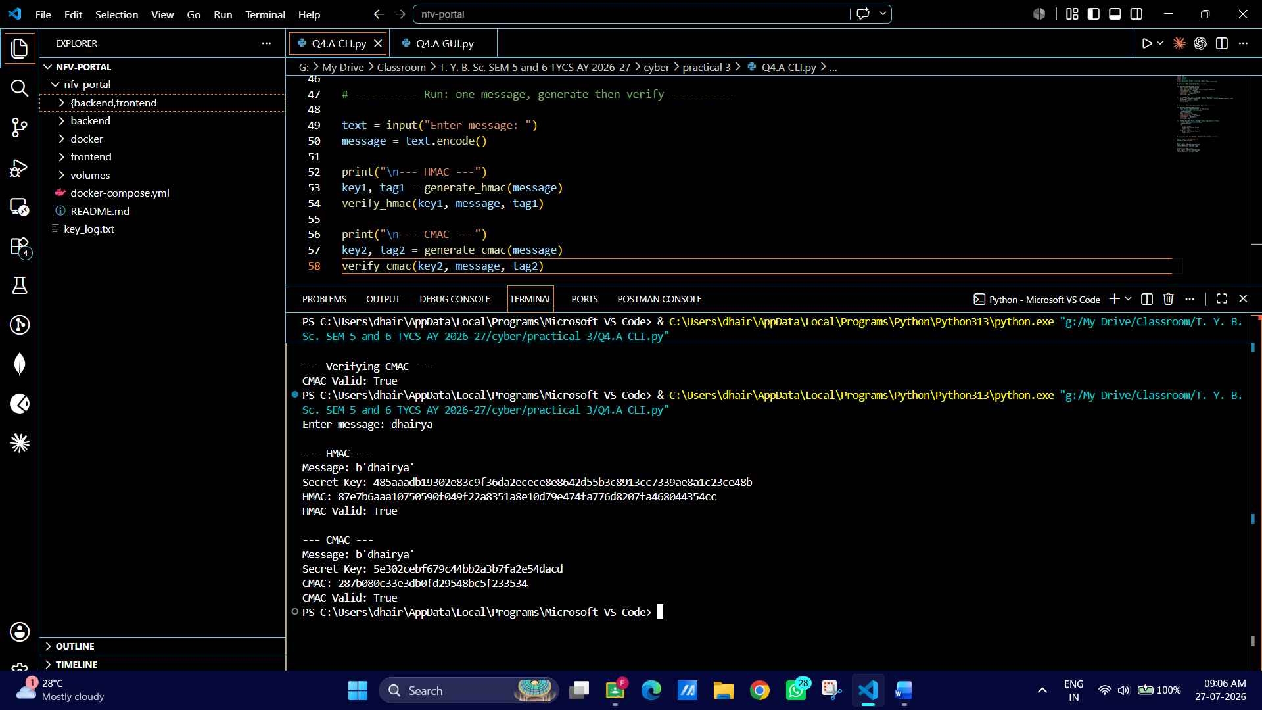

GUI: INPUT
import tkinter as tk
from tkinter import messagebox
import hmac
import hashlib
import secrets
from cryptography.hazmat.primitives import cmac
from cryptography.hazmat.primitives.ciphers import algorithms

# ---------- HMAC (hash-based MAC) ----------

def generate_hmac(message: bytes):
key = secrets.token_bytes(32)
tag = hmac.new(key, message, hashlib.sha256).digest()
return key, tag

def verify_hmac(key: bytes, message: bytes, tag: bytes) -> bool:
return hmac.compare_digest(hmac.new(key, message, hashlib.sha256).digest(), tag)

# ---------- CMAC (AES block-cipher-based MAC) ----------

def generate_cmac(message: bytes):
key = secrets.token_bytes(16) # AES-128 key
c = cmac.CMAC(algorithms.AES(key))
c.update(message)
tag = c.finalize()
return key, tag

def verify_cmac(key: bytes, message: bytes, tag: bytes) -> bool:
c = cmac.CMAC(algorithms.AES(key))
c.update(message)
try:
c.verify(tag)
return True
except Exception:
return False

# ---------- shared state (holds last generated keys/tags) ----------

state = {"message": None, "hmac_key": None, "hmac_tag": None,
"cmac_key": None, "cmac_tag": None}

# ---------- GUI actions ----------

def do_generate():
text = entry.get().strip()
if not text:
messagebox.showwarning("Input needed", "Please enter a message.")
return
message = text.encode()

hkey, htag = generate_hmac(message)
ckey, ctag = generate_cmac(message)

state["message"] = message
state["hmac_key"], state["hmac_tag"] = hkey, htag
state["cmac_key"], state["cmac_tag"] = ckey, ctag

output.delete("1.0", tk.END)
output.insert(tk.END, f"Message: {text}\n")
output.insert(tk.END, f"Encoded: {message}\n\n")

output.insert(tk.END, "--- HMAC Generated ---\n")
output.insert(tk.END, f"Secret Key: {hkey.hex()}\n")
output.insert(tk.END, f"HMAC: {htag.hex()}\n\n")

output.insert(tk.END, "--- CMAC Generated ---\n")
output.insert(tk.END, f"Secret Key: {ckey.hex()}\n")
output.insert(tk.END, f"CMAC: {ctag.hex()}\n")

def do_verify():
if state["hmac_key"] is None:
messagebox.showwarning("Nothing to verify", "Generate the MACs first.")
return

text = entry.get().strip()
if not text:
messagebox.showwarning("Input needed", "Please enter a message to verify.")
return
message = text.encode() # re-read current box content, not the stored one

hmac_valid = verify_hmac(state["hmac_key"], message, state["hmac_tag"])
cmac_valid = verify_cmac(state["cmac_key"], message, state["cmac_tag"])
output.insert(tk.END, f"HMAC Valid: {hmac_valid}\n")
output.insert(tk.END, f"CMAC Valid: {cmac_valid}\n")

# ---------- GUI layout ----------

root = tk.Tk()
root.title("MAC Generator - HMAC & CMAC")
root.geometry("560x480")

tk.Label(root, text="Enter Message:").pack(pady=(10, 0))
entry = tk.Entry(root, width=60)
entry.pack(pady=5)

tk.Button(root, text="Generate HMAC & CMAC", command=do_generate).pack(pady=5)
tk.Button(root, text="Verify HMAC & CMAC", command=do_verify).pack(pady=5)

output = tk.Text(root, width=68, height=18, wrap="word")
output.pack(pady=10)

root.mainloop()

Output:
